Sierra Leone

## Population Data

The data set shows the political stability estimate of the country each year.

## # A tibble: 23 x 5  
## country iso3c date population popCategory5  
## <chr> <chr> <dbl> <dbl> <chr>   
## 1 Sierra Leone SLE 1996 4312666 very small   
## 2 Sierra Leone SLE 1997 4335301 very small   
## 3 Sierra Leone SLE 1998 4381483 very small   
## 4 Sierra Leone SLE 1999 4462378 very small   
## 5 Sierra Leone SLE 2000 4584571 very small   
## 6 Sierra Leone SLE 2001 4754072 very small   
## 7 Sierra Leone SLE 2002 4965766 very small   
## 8 Sierra Leone SLE 2003 5201070 small   
## 9 Sierra Leone SLE 2004 5433991 small   
## 10 Sierra Leone SLE 2005 5645624 small   
## 11 Sierra Leone SLE 2006 5829237 small   
## 12 Sierra Leone SLE 2007 5989633 small   
## 13 Sierra Leone SLE 2008 6133603 small   
## 14 Sierra Leone SLE 2009 6272734 small   
## 15 Sierra Leone SLE 2010 6415634 small   
## 16 Sierra Leone SLE 2011 6563240 small   
## 17 Sierra Leone SLE 2012 6712581 small   
## 18 Sierra Leone SLE 2013 6863980 small   
## 19 Sierra Leone SLE 2014 7017144 small   
## 20 Sierra Leone SLE 2015 7171914 small   
## 21 Sierra Leone SLE 2016 7328838 small   
## 22 Sierra Leone SLE 2017 7488431 small   
## 23 Sierra Leone SLE 2018 7650154 small

# Population growth data

## # A tibble: 23 x 5  
## country iso3c date popGrowth popGrowthCat5   
## <chr> <chr> <dbl> <dbl> <chr>   
## 1 Sierra Leone SLE 1996 0.202 slow growth rate   
## 2 Sierra Leone SLE 1997 0.523 slow growth rate   
## 3 Sierra Leone SLE 1998 1.06 slow growth rate   
## 4 Sierra Leone SLE 1999 1.83 moderate growth rate  
## 5 Sierra Leone SLE 2000 2.70 high growth rate   
## 6 Sierra Leone SLE 2001 3.63 high growth rate   
## 7 Sierra Leone SLE 2002 4.36 high growth rate   
## 8 Sierra Leone SLE 2003 4.63 high growth rate   
## 9 Sierra Leone SLE 2004 4.38 high growth rate   
## 10 Sierra Leone SLE 2005 3.82 high growth rate   
## 11 Sierra Leone SLE 2006 3.20 high growth rate   
## 12 Sierra Leone SLE 2007 2.71 high growth rate   
## 13 Sierra Leone SLE 2008 2.38 moderate growth rate  
## 14 Sierra Leone SLE 2009 2.24 moderate growth rate  
## 15 Sierra Leone SLE 2010 2.25 moderate growth rate  
## 16 Sierra Leone SLE 2011 2.27 moderate growth rate  
## 17 Sierra Leone SLE 2012 2.25 moderate growth rate  
## 18 Sierra Leone SLE 2013 2.23 moderate growth rate  
## 19 Sierra Leone SLE 2014 2.21 moderate growth rate  
## 20 Sierra Leone SLE 2015 2.18 moderate growth rate  
## 21 Sierra Leone SLE 2016 2.16 moderate growth rate  
## 22 Sierra Leone SLE 2017 2.15 moderate growth rate  
## 23 Sierra Leone SLE 2018 2.14 moderate growth rate

## Population trend

The plot shows the population trend of the country.

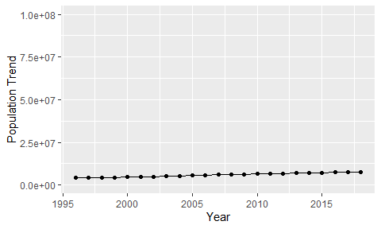

Political Stability Trend

# Population growth trend

The plot shows the population growth rate trend of the country.

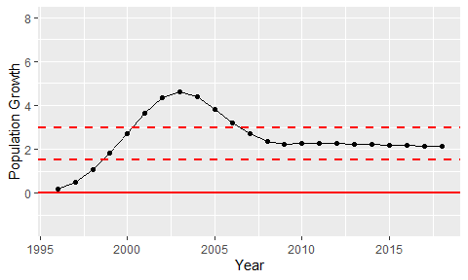

Population Growth Trend